     | UNIVERSITY OF COLOMBO SCHOOL OF COMPUTING  (Successor to the Institute of Computer Technology (ICT))  UNIVERSITY OF COLOMBO, SRI LANKA
DEGREE OF BACHELOR OF INFORMATION TECHNOLOGY (EXTERNAL)
Academic Year 2002/03 – 2nd Year Examination – Semester 3

IT3101: Object Oriented Systems Development

PART 2 – Structured Question Paper

22nd February, 2003
(ONE AND A HALF HOURS

To be completed by the candidate

BIT Examination Index No:

Important Instructions:

- The duration of the paper is 1 ½ (one and a half) hours.
- The medium of instruction and questions is English.
- The paper has 4 questions and 16 pages.
- Answer question 1 and any two of the other questions only.
- All questions will carry equal marks.
- Write your answers in English using the space provided in this question paper.
- Do not tear off any part of this answer book.
- Under no circumstances may this book, used or unused, be removed from the Examination Hall by a candidate.
- Note that questions appear on both sides of the paper.
If a page is not printed, please inform the supervisor immediately.

Questions Answered
Indicate by a cross (×), (e.g. 1 ) the numbers of the three questions answered.
 | Question numbers
To be completed by the candidate by  marking a cross (×). | 1 | 2 | 3 | 4
To be completed by the examiners:

×

Based on the following case study answer question 1.

Instructions to the Candidate.
- Please read the case and submit answers to the questions below in the space provided.
- Carefully plan your answers before starting to write.

 | 1) |  |  |  | The following text describes the operations of an Airline Reservation System:
 |  |  |  |  | Reservations can be done by individuals or by agencies (type of customer). For block bookings which are done by agencies, discounts are given.
 |  |  |  |  | When a customer wants to make a reservation, at the airline office, the airline officer will take notes of the date of departure, the departure point, destination point and the class the customer wishes to travel in to check the availability of a flight.
 |  |  |  |  | If a flight is available according to the customer’s requirements, a confirmed reservation is made under the customer’s name by taking the following particulars.
 |  |  |  |  | Customer’s name, Passport Number and contact number(s)
 |  |  |  |  | After making the reservation, the customer is informed of the flight number and departure time with the routes of the reserved flight.
 |  |  |  |  | A route can be defined as a point-to-point journey between the reservation’s starting point and the final destination. There may be some stopovers. As a result, different flights may be used to reach the reservation’s final destination. Hence, a reservation may not necessarily take a direct flight to the final destination. The type of aircraft is fixed for each point-to-point journey. Same flight may involve several stopovers and the same or different aircraft may be used for the next succeeding stage.
 |  |  |  |  | If a flight is not available according to the requirements of the customer, the customer is requested to make a tentative reservation for that specific flight. If the customer agrees, a tentative reservation is made for him and the customer is informed of the flight number, departure date and time with the routes of that flight.
 |  |  |  |  | If the customer wants to leave on a specific date and if he agrees with any flight as long as it leaves on that date, the reservation is made tentatively without any flight attached.
 |  |  |  |  | The individual customers are required to pay 50% of the fare as an advanced payment when they reserve a flight but this is not applicable to block bookings done by agencies.
 |  |  |  |  | The fare depends on the following factors.
 |  |  |  |  | Type of seat class, Type of customer, Flight
 |  |  |  |  | Individuals are required to pay the balance amount when they come to the airline office to collect the ticket. Agencies have to settle the payment within a duration of one month from the date of reservation.
Discounts are also given for different payment modes.
They are as follows:

Payment Modes Discount
Cash No discount
Traveller’s Cheque e.g. 2% Thomas Cook
Credit Card e.g. 3% Diners etc.
Block Booking Depend on the agency.

 |  |  |  |  | Finally, when a customer checks in at the airport of departure, the checking officer gives a boarding pass to the customer comprising the following information.
 |  |  |  |  | Flight number, Seat number, Boarding gate and time
 |  |  |  |  | (a) Following is a Use Case diagram for the given system:
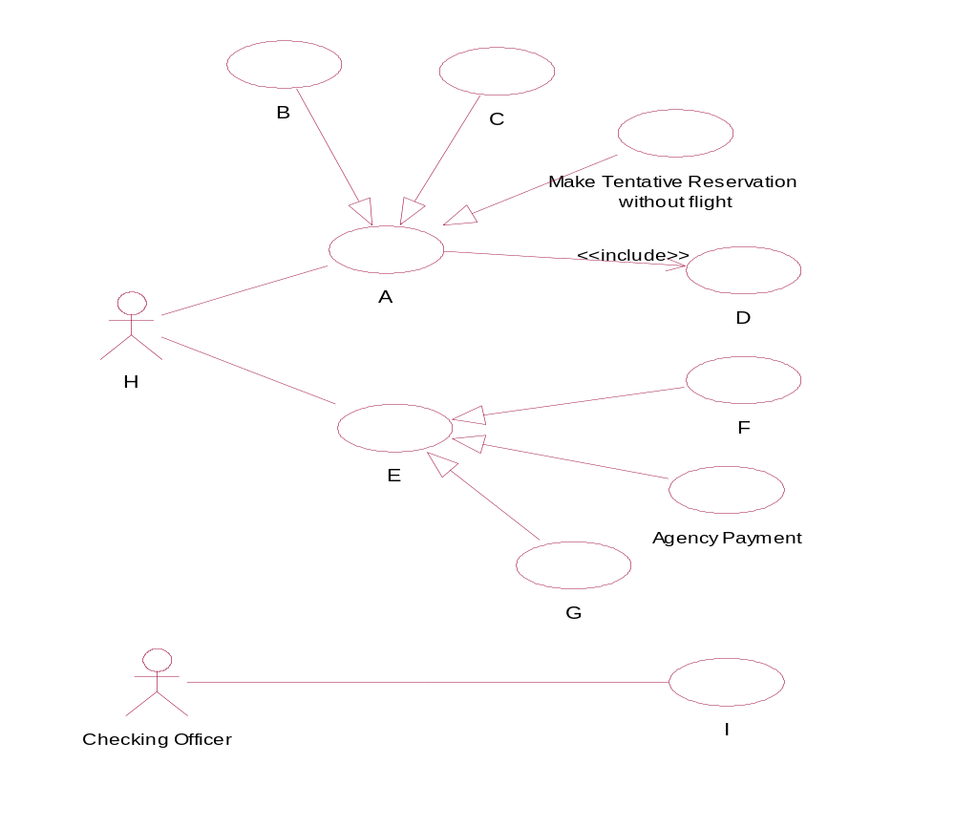

Identify the Actors/Use Cases for labels A-I.

(20% Marks)
 |  |  |  |  |  |  | ANSWER IN THIS BOX
(A) (B)
(C) (D)
(E) (F)
(G) (H)
(I)
Make Reservation Make Block Reservation
Make tentative Reservation with flight Check Available flights
Make Payment Cash Payment
Credit Payment Airline officer
Issue Boarding Pass
 |  |  |  |  | (b) Identify the potential classes for the above system.
 |  |  |  |  | (30% Marks)
ANSWER IN THIS BOX
Aircraft Customer
IndividualCustomer AgencyCustomer
Passenger Invoice
CashPayment CreditCardPayment
Payment TravellersCheckPayment
Flight Seat
StopOver Discount
FlightSchedule Reservation

BoardingPass

 |  |  |  |  | (c) Identify the static relationships between the above classes.
 |  |  |  |  | (30% Marks)
 |  |  |  |  |  | ANSWER IN THIS BOX
Class name Class name Relationship (UML notation)
Flight FlightSchedule Aggregation(Composition)
Flight Schedule StopOver Aggregation(Composition)
StopOver Aircraft Association
Aircraft Seat Aggregation(Composition)
FlightSchedule Reservation Association
Passenger Reservation Association
Reservation Boarding pass Association
Invoice Reservation Association
Customer Invoice Association
Invoice Payment Association
Discount Payment Association
CreditCardPayment Payment Inheritance
TravellersCheckPyment Payment Inheritance
CashPayment Payment Inheritance
Customer AgencyCustomer Inheritance
Customer IndividualCustomer Inheritance

 |  |  |  |  | (d) Identify the object(s) responsible for the Use Case C in (a).
 |  |  |  |  | (20% Marks)
ANSWER IN THIS BOX
Reservation, Customer, Flight
 |  |  |  |  |  |  | If C is Make tentative Reservation with flight :
If C is Block Reservation :
Invoice, Agency, Reservation, Flight, Customer
 | 2) |  |  | (a) (i) List three advantages in Object Oriented methodology of systems development over the traditional Structured approach.
 |  |  |  | (30% Marks)
ANSWER IN THIS BOX
Reusability

Reliability

Extensibility, Robustness, Distributability etc
(i)

(ii)

(iii)

(ii) Design Patterns are solutions found to recurring problems when designing a system. Name the design pattern you would use, if you want to ensure that only a single instance of a class exists at any time.

(10% Marks)
ANSWER IN THIS BOX
Singleton Pattern
(iii) When designing a system, decoupling the user interface objects and domain objects is highly desirable. If done well, the user interface can be replaced with minimal changes to domain classes. If a domain object needs to communicate with a user interface object, what is the pattern that can be used to achieve this flexibility?

(10% Marks)
ANSWER IN THIS BOX

Publish and Subscribe / Model-View Separation / Push Observer

 |  |  |  |  | (b) Consider the following program:
class Base  {  public:  int x;  }; | class Derived3 : public Derived1, public Derived2  {  public:  int sum;  Derived3(int a, int b, int c)  {  x=a;  y=b;  z=c;  }  void ShowSum()  {  cout << x+y+z << endl;  }  };
class Derived2 : public Base
{
public:
int z;
};

class Derived1 : public Base
{
public:
int y;
};
void main()
{
Derived3 ob1(5,10,20);
ob1.ShowSum();
}

(i) It has been found out that the class Derived3 cannot be compiled because it gave compilation errors. What is the problem with this class?
(10% Marks)
 |  |  |  |  |  |  | ANSWER IN THIS BOX
Derived 3 has attribute x, inherited from Both Derived1 and Derived2. Hence in lines

x=a;

cout << x+y+z << endl;
use of x is ambiguous.

(ii) Give two methods to resolve the above problem.
(30% Marks)
ANSWER IN THIS BOX
Use Virtual key word to Inherit from Base class as follows
class Derived1 : virtual public Baseclass Derived2 : virtual public Base

Use the Scope Resolution Operator to resolve ambiguity as follows
Derived1::x=a; OR Derived2::x=a;
cout << Derived1::x+y+z << endl; OR cout << Derived2::x+y+z << endl; Note that the combination Derived1::x=a; OR Derived2::x+y+z << endl; and vice-versa will not work
(a)

(b)
 |  |  |  |  |  |  | OR
(c)
Base Derived1 Derived2 Derived3
 |  |  |  |  | (iii) What would be the output of the program once the problem has been resolved using any of the above methods?
 |  |  |  |  | (10% Marks)
 |  |  |  |  |  |  | ANSWER IN THIS BOX
 |  |  |  |  |  |  | 35
 | 3) |  |  |  | (a) The ABC Theatres Ltd. is one of the leading theatre groups in this country. Different shows are organized by this group throughout the year. The seats in the theatre are divided into sections and the ticket price for a seat in each section for different shows may vary. When a ticket is purchased, customers are presented with the Show schedule from which they can pick a show. Then the prices of seats per section for that show are shown to the customer. If Customer wishes to go ahead with the purchase, he/she can choose available seats from a box plan. When the customer chooses the required number of seats from a preferred location, he/she is presented with the Total amount. Payments can be made by cash or by credit card. The Customers can Purchase a ticket for a lower price if they are paying by certain credit cards and hence, marked price and the purchased price of a ticket may vary. Once the payment is done, the Purchasing is completed. The details of the Purchase, payment information and the customer information are stored. Then the customer is issued with the tickets for the show. A single purchase is for a Particular show and if the Customer wishes to purchase (a) ticket(s) for another show, then a new purchase will be created. There can be multiple Purchases for the same seat for different schedules.
 |  |  |  |  | The following classes have been identified by the Systems Analyst in his first iteration for this scenario.
 |  |  |  |  | You are required to draw the relationships and indicate multiplicity between the above classes on the class diagram.
 |  |  |  |  | (40% Marks)
ANSWER IN THIS BOX
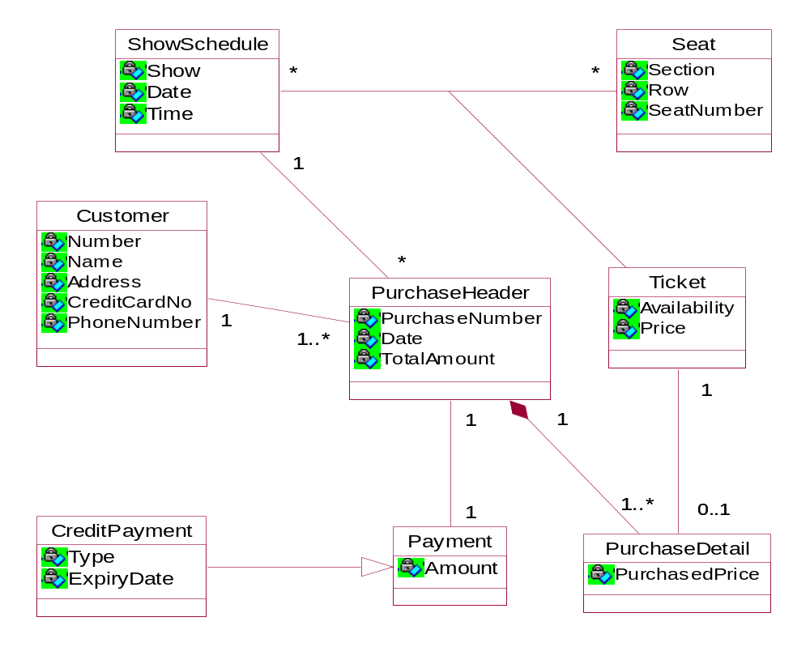
 |  |  |  |  | (b) Consider the following Flow of events and the Sequence diagram for simplified PurchaseTickets Scenario, of the ABC Theatres Ltd. This was developed by the systems analyst in one of his early iterations. Please note that operations 5 to 9 will be repeated until no more seats are there to enter.
 |  |  |  |  | Flow of events:
 |  |  |  |  | - This Scenario begins when customer wishes to Purchase Tickets for a show after examining the Show Schedule, Sectional seat prices and available Seating arrangements.
Main Flow | Alternate Flows
Actor Initiates New Purchase  Enter Customer Information  Create Purchase Header  REPEAT  Select Ticket  Create Purchase Detail  Set Ticket Unavailable  UNTIL no more tickets to be selected  Set Total Amount in Purchase Header  Display Grand Total  Actor Initiates New Payment  Enter Customers Cash amount  IF Insufficient Cash amount THEN E-1  Re-Enter Customers Cash amount  ELSE  Set Payment Information  CreatePaymentObject  Display Customers Balance  END IF | E-1 Message “Insufficient Cash Amount”

 |  |  |  |  | Sequence diagram:
 |  |  |  |  | 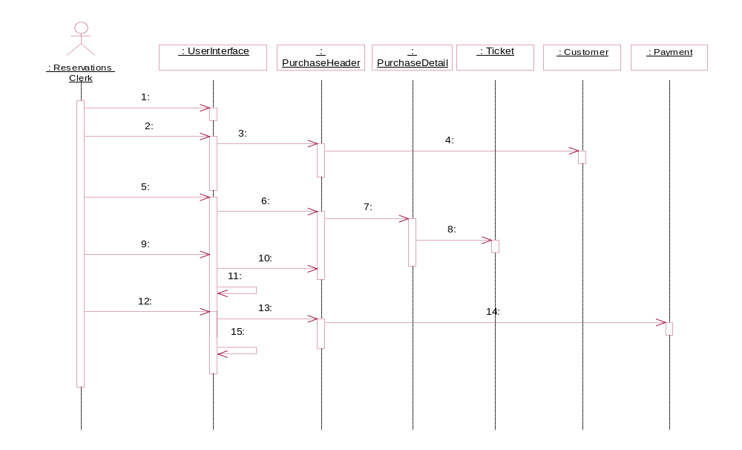
Also consider the list of messages given below.
- SelectTicket( )  - CreateHeader( )  - SetCustomerInfo( )  - DisplayGrandTotal( )  - FinishedSelection( )  - CreatePayment( )  - DisplayBalance( ) | - CreateCustomer( )  - SetUnavilable( )  - CreateDetail( )  - NewPayment( )  - NewPurchase( )  - SetPaymentInfo( )  - NewPurchaseDetail( )  (o) GetGrandTotal( )

Fill in the blanks with the appropriate message from the list.
(30% Marks)
ANSWER IN THIS BOX

1: …………
4: …………
7: …………
10: …………
13: …………
2: …………
5: …………
8: …………
11: …………
14: …………
3: …………
6: …………
9: …………
12: …………
15: …………
l

c / h

b
h / c

a

n / j
j / n

i

e
0

d

k
m

f

g
 |  |  |  |  | (c) Consider the following description of the class ticket:
 |  |  |  |  | The ticket object may undergo many state changes during its lifetime. Initially it will be in the state Available. Privileged Customers (who have purchased tickets for two or more previous shows) can reserve a ticket by phoning in giving their National ID card /Passport numbers. The actual payment must be made before a deadline (3 days prior to scheduled date of the show) and if not, their reservations will be automatically cancelled by the system and the reserved tickets will be available to other customers. If they pay on time, then the ticket object will move to the Purchased state. Customers can also directly purchase an available ticket from the ticketing counter. Any ticket not purchased by customers till the end of the show(tickets in available state) will be moved to the state Closed by the system.
 |  |  |  |  | You are provided with the following State Chart Diagram, States, Events and Guard conditions.
State Chart diagram:
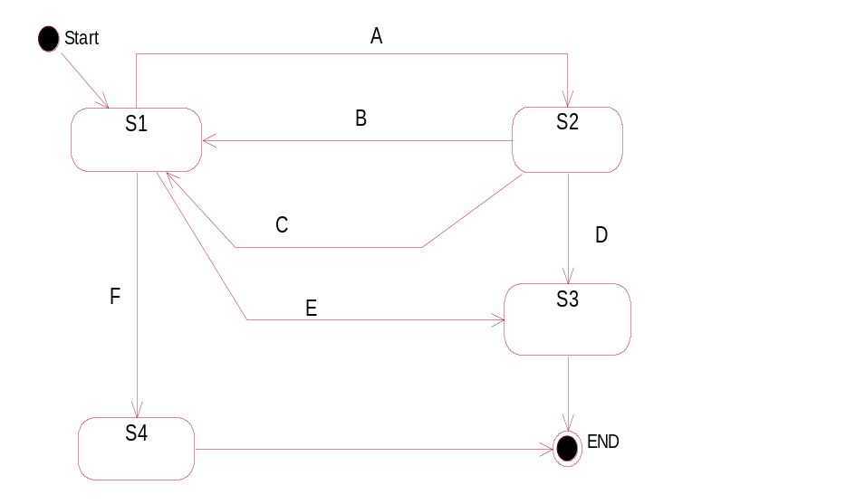
States:

  - Purchased
  - Reserved
  - Closed
  - Available

Events and Guard conditions:

  - Payment for Reservation [Reservation exists in Reserved state ]
  - EndOfShow[ InAvailableState ] / Close
  - Purchase a Ticket / PurchaseTicket
  - Cancel a Reservation( Identification No ) / CancelReservation
  - ReserveTicket( Identification No )[ Privileged Customer ]
  - PaymentDeadlinePassed / AutomaticReservationCancellation.

Fill in the blanks with appropriate States, Events and Guard conditions from the above list.
(30% Marks)
ANSWER IN THIS BOX
d

b

a

c

i
h/j

h/j

e

g

f
S1

S2

S3

S4

A
B

C

D

E

F

 | 4) |  |  |  | Consider the following class Diagram:  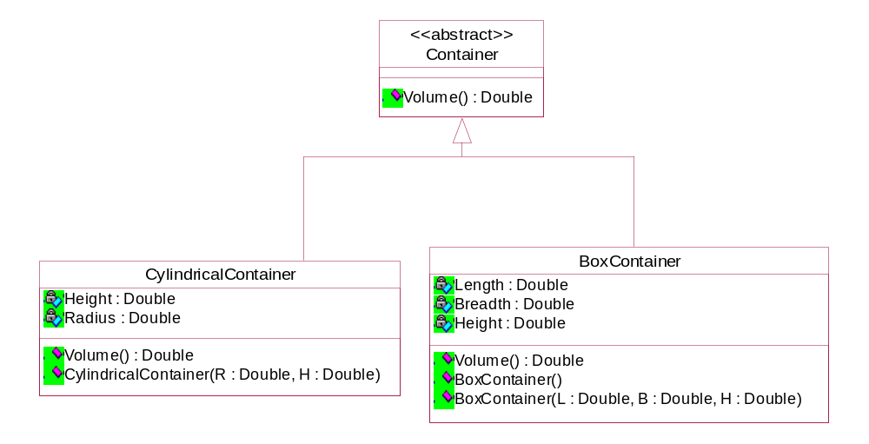  The Default Constructor in the class BoxContainer will create a BoxContainer object with Length, Breadth and Height of one Unit. It is necessary to ensure that BoxContainer attributes are positive and therefore, the other constructor must set any negative values supplied for attributes to 1.  The Volume of a Cylinder can be found with the following formula:  Volume = PI * Radius*Radius*Height where PI=3.14159  It is required to map the above class diagram to C++ code.
 |  |  |  |  | (i) Write the C++ Definition of class Container.
 |  |  |  |  | (10% Marks)
ANSWER IN THIS BOX
class Container

{
public:

virtual double Volume()=0;
};

 |  |  |  |  | (ii) Write the C++ Definition of class BoxContainer. (Method implementation is not needed.)
 |  |  |  |  | (10% Marks)
 |  |  |  |  |  |  | ANSWER IN THIS BOX
class BoxContainer : public Container
{
double Length, Breadth, Height;

public:

BoxContainer();

BoxContainer(double L, double B, double H);

double Volume();

};

 |  |  |  |  | (iii) Implement the Two BoxContainer constructors.
 |  |  |  |  | (10% Marks)
ANSWER IN THIS BOX
BoxContainer()
{

Length = Breadth = Height = 1.0;
}
(a)

(b)
BoxContainer(double L, double B, double H)
{

Length = L>0 ? L : 1;
Breadth = B>0 ? B : 1;
Height = H>0 ? H : 1;

}
(iv) Implement the Volume function in class CylindricalContainer.
(05% Marks)
 |  |  |  |  |  |  | ANSWER IN THIS BOX
double Volume()
{
return Radius*Radius*Height*3.14159;
}
(v) Implement a member function in class BoxContainer so that one can write expressions of the form
BC1 > BC2
where BC1 and BC2 are BoxContainer objects. The comparison should be done based on the volumes of the two objects.
 |  |  |  |  | (10% Marks)
 |  |  |  |  |  |  | ANSWER IN THIS BOX
bool BoxContainer::operator>(BoxContainer ob)
{
return Volume() > ob.Volume();
}

(vi) Write the global function called displayVolume which can display the volume of either a BoxContainer or a CylindricalContainer according to the objects which have been passed into the displayVolume as parameters, to illustrate runtime polymorphism.
(10% Marks)
void displayVolume(Container *C)
{
cout << C->Volume() << endl;
}

(vii) Fill in the blanks in the following main() function:
(45% Marks)
ANSWER IN THIS BOX
void main()
{
// Create a BoxContainer Object BC1 with each attribute set to 1 unit

BoxContainer BC1;
OR
BoxContainer BC1(1,1,1);

// Create a BoxContainer Object BC2 with units 2, 3, 4 for
// Length,Breadth and Height respectively

BoxContainer BC3(2,3,4);

// Create a CylindricalContainer Object CC1 with
// Radius of 7 units and Height of 5 units

// Display volume of the Largest of the BC1 and BC2 Boxcontainers using
// overloaded operator

 |  |  |  |  |  | BoxContainer BC3(2,3,4);
// Display Volume of BC2 using displayVolume function

displayVolume(&BC2);
 |  |  |  |  |  | // Create a CylindricalContainer Object CC1 with Radius of 7 units and Height of 5 units
 |  |  |  |  |  | CylindricalContainer CC1(7,5);
 |  |  |  |  |  | // Display Volume of CC1 using displayVolume function
 |  |  |  |  |  | displayVolume(&CC1);
 |  |  |  |  |  | // Display volume of the Larger of the BC1 and BC2 Boxcontainers using overloaded operator
if(BC1 > BC2)
cout << " Volume of BC1" << BC1.Volume() << endl;
else cout << " Volume of BC2" << BC2.Volume() << endl;

 |  |  |  |  |  |  |  |  | }
********

